- nl_svm & nl_svm
  - Macro:
    - RMSE: 1859.4158647682689
    - Relative RMSE: 0.45281893982197197
    - MAE: 1416.8371795321343
    - Adjusted R2: 0.794287729753461
  - Micro:
    - Average total RMSE: 0.008403222155056901
    - Average total adjusted R2 score: 0.2984238233162606
  - 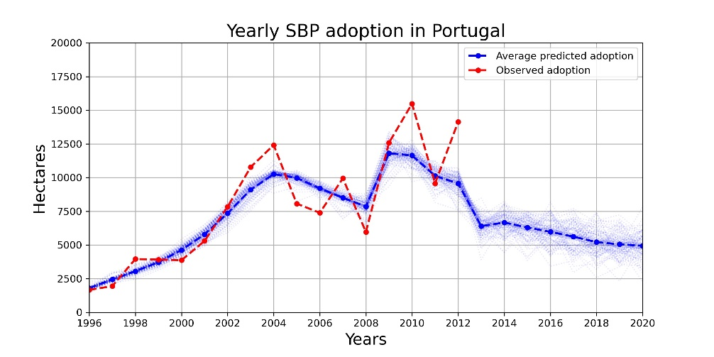
- xgb_clsf & nl_svm
  - Macro:
    - RMSE: 1683.0382964437435
    - Relative RMSE: 0.409866147490579
    - MAE: 1365.3512929788722
    - Adjusted R2: 0.8314630503871578
  - Micro:
    - Average total RMSE: 0.00780685336555331
    - Average total adjusted R2 score: 0.39447066494486904
  - 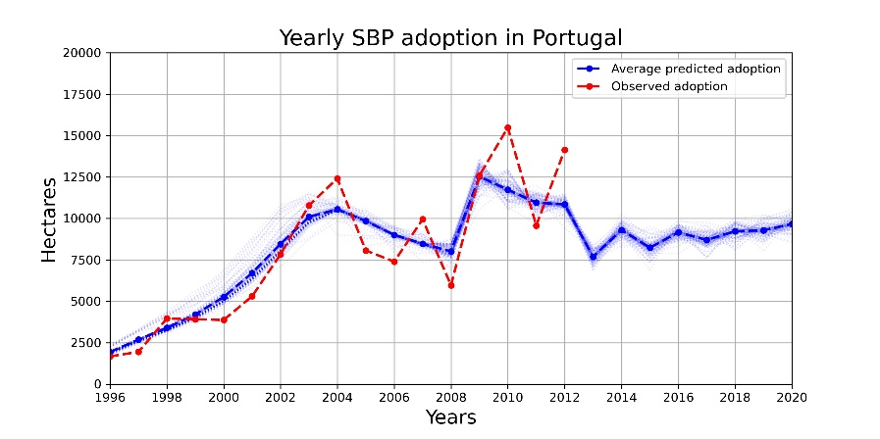
- nl_svm & extr_for_reg
  - Macro:
    - RMSE: 1858.4597171780874
    - Relative RMSE: 0.4525860915676879
    - MAE: 1335.543355240745
    - Adjusted R2: 0.7944992378124813
  - Micro:
    - Average total RMSE: 0.008294631008747902
    - Average total adjusted R2 score: 0.31643898642126045
- xgb_clsf & extr_for_reg
  - Macro:
    - RMSE: 1781.729325755228
    - Relative RMSE: 0.4339001294036756
    - MAE: 1319.3492554508532
    - Adjusted R2: 0.8111179927866555
  - Micro:
    - Average total RMSE: 0.008214117412070879
    - Average total adjusted R2 score: 0.3296448412928915

